EPOS System Test Log

|  |  |  |  |  |
| --- | --- | --- | --- | --- |
| **Software Development** | | | | |
| Test Data | | | | |
| Test No. | User Action | Expected Result | Actual Result | Pass / Fail |
| 1 | User Login | Manager Features removed. | Manager tab is removed as expected. | Pass |
| 2 | Manager Login | All features available. | Manager tab remains visible as expected. | Pass |
| 3 | Select a quantity then a product | The “Quantity” number of the selected item will be added to the basket. | The product is added to the order corresponding with the quantity. | Pass |
| 4 | Add products to an order | Products added to order. | The product is added to the order as expected. | Pass |
| Item details displayed synchronously. | The details are displayed alongside the product. | Pass |
| Sales total updated and displayed synchronously. | The total is updated and displayed synchronously. | Pass |
| Users reports updated synchronously. | The user’s report updates upon checking out. | Pass |
| 5 | Checkout | Feedback and sale cost displayed to user. Sales data saved. | Messagebox displays price and sales data is saved. | Pass |
| 6 | Clear an order | Order will be cleared. | Order cleared and price reset. | Pass |
| 7 | View reports | User’s report should show. | User’s report is visible and accurate. | Pass |
| Total customers served. | Visible and accurate. | Pass |
| Total sales cost. | Visible and accurate. | Pass |
| Minimum sale value. | Visible and accurate. | Pass |
| Maximum sale value. | Visible and accurate. | Pass |
| Average sale value. | Visible and accurate. | Pass |
| 8 | Sales Restart | Clears the database of all sales. | The sales table is cleared of all entries and the EPOS system resets properly. | Pass |

Screenshots

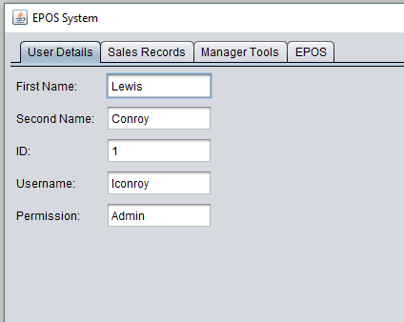

I successfully logged in as an admin.

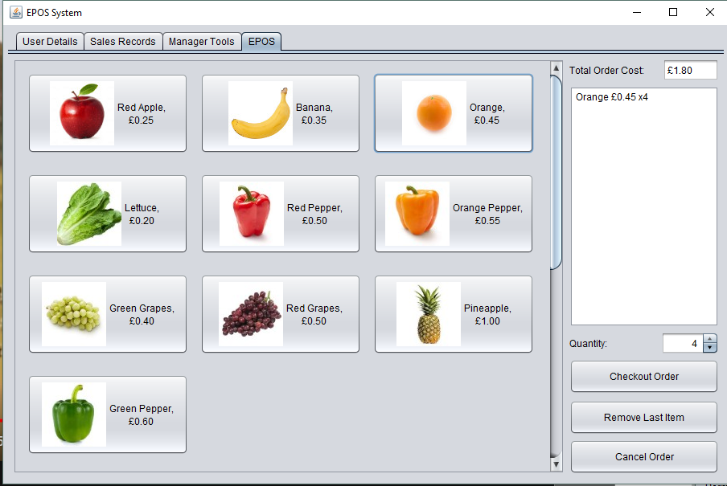

I set the quantity to four, and successfully added four oranges to my order.

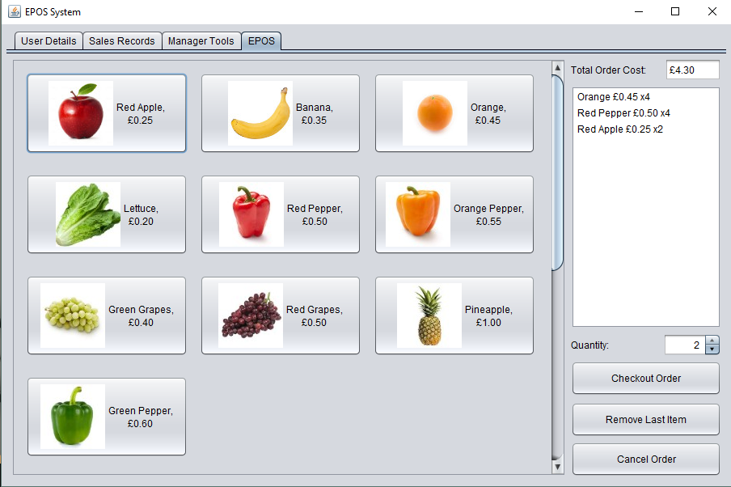

The order and cost update synchronously as items are added to the order.

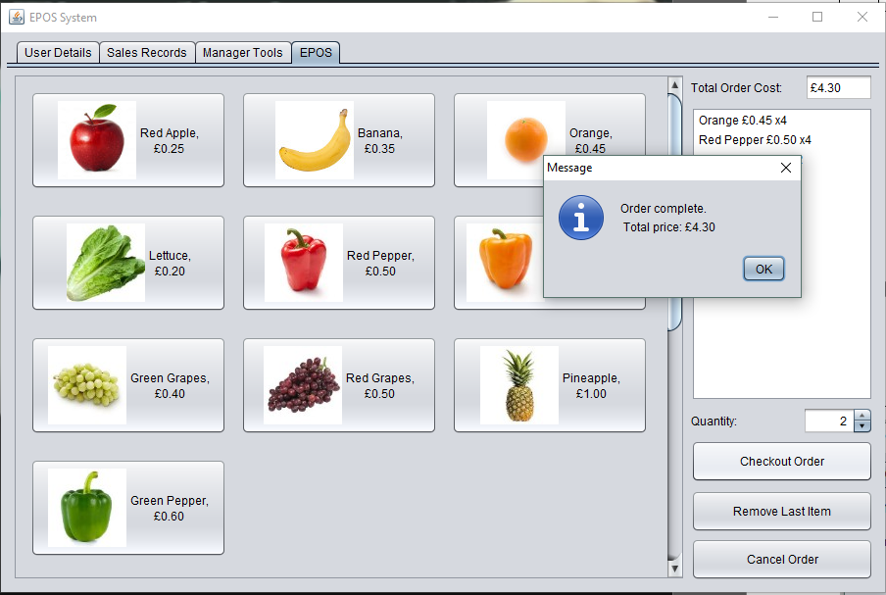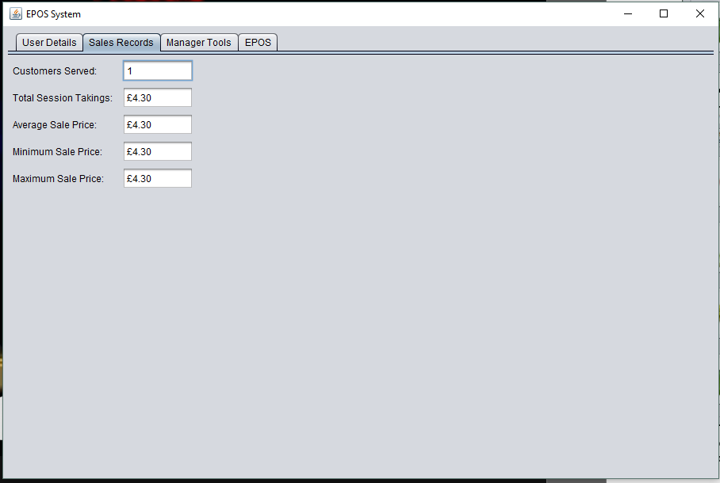

The checkout button completes the order and displays a message box. The order is then cleared, and the records are updated.

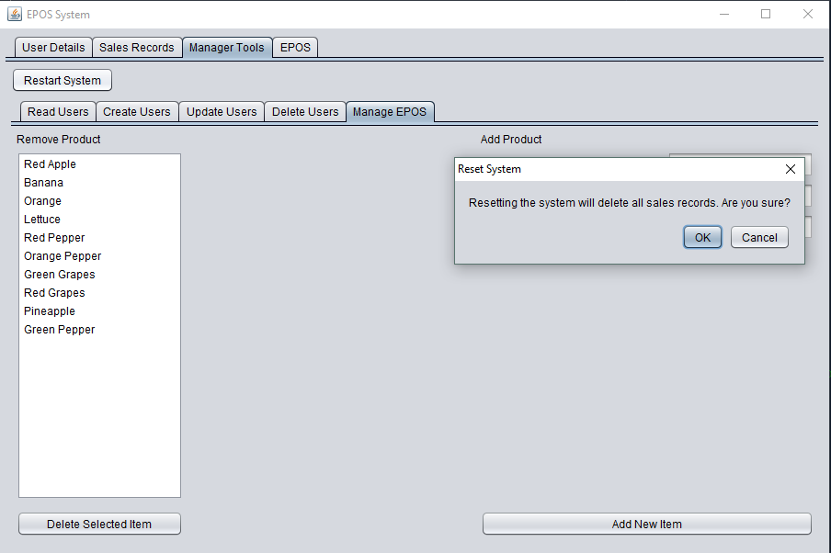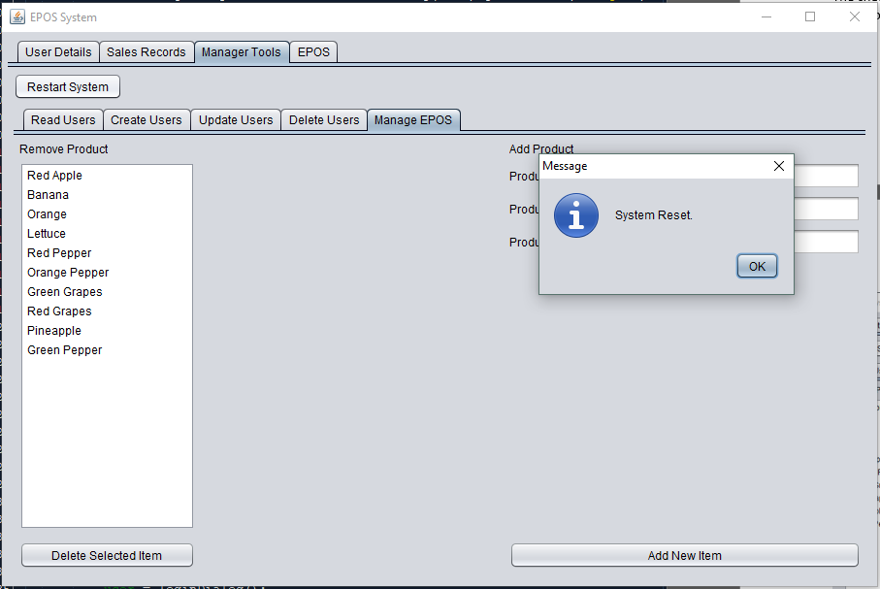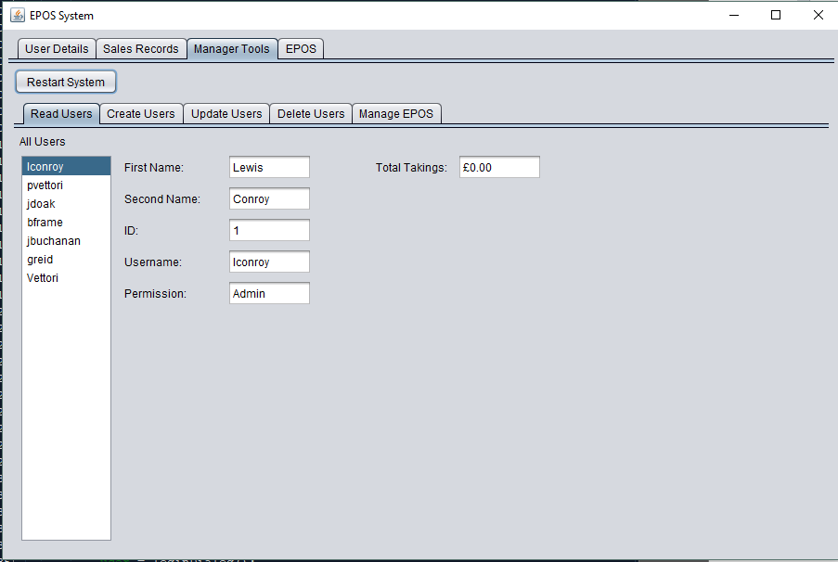

The reset button prompted the user to confirm, and then successfully cleared the sales table. You can see that lconroy no longer has any takings.